ABSTRACT
Human dental pulp stem cells (hDPSCs) are adult stem cells with great therapeutic potential in regenerative medicine because of their broader differentiation capabilities. Dental pulp is soft tissues which comprises of neural fibers, blood vessels as well as connective tissue; the HDPSCs are located at the center of the tooth .Other dental tissues such as exfoliated deciduous teeth (SHED), periodontal ligament (PDLSCs), apical papilla (SCAP) and dental follicle progenitor cells (DFPCs) are the sources of the stem cells. HDPSCs are known to be heterogenous in nature having different subtypes; one subtype of the stem cells originates from migrating neural crest cells, while another subtypes originates from mesodermal and ectodermal lineage. These stem cells have wide differentiation potential and have been differentiated into a variety of cell types such as osteoblasts, chondrocytes, adipocytes, neurons, myocytes, liver cells, epithelial cells of cornea, skin cells, dentin forming odontoblasts and Beta cells. The aim of this study was to evaluate the impact on the isolation and characterization of stem cells from human dental pulp tissues with the surface markers CD45⁻ and CD34⁺. For the purpose the presented protocol deliberates the methodology for generating more purifies DPSC preparations. The process comprise enzymatic digestion accompanied by isolation of DPSC, counting and characterization with flow cytometry. Thereby the hDPSCs populations were also evaluated for their multilineage differentiation potential, namely they were induced towards osteogenic, myogenic, adipogenic and neurogenic lineages.

CHAPTER I
INTRODUCTION

Pluripotent stem cells possess the inherent property of differentiating to several kinds of cells in the human body. Various research developed mesenchymal stem cells (MSCs) from different human tissues, body fluids and peripheral blood. In order to understand the phenotypic nature, these stem cells are characterized by molecular and cellular markers. Human dental pulp stem cells (hDPSCs) are considered as a striking target for therapeutic applications due to their inherent tendency and neural crest origin. DPSCs have MSC phenotype and are characterized to cardiomyocytes, neuron, osteoblasts, liver cells, chondrocytes, and beta cells of pancreas. Accordingly DPSCs depicted greater potentiality in regenerative medicine for treating several dental diseases in human. These cells could also be effectively developed to induced pluripotent SC through incorporating pluripotent markers. DPSCs can be extracted from several dental tissues like apical papilla, human exfoliated deciduous teeth, dental follicle tissue and periodontal ligament. This chapter will provide the introduction about the isolation, counting, differentiation and molecular characterization of DPSCs to different kinds of human cells and hence these cells possess significant applications in the regenerative therapy. This chapter would emphasize the clear principles of the methodologies followed in this study.

HUMAN DENTAL PULP STEM CELLS (HDPSCS)

Dental Pulp tissue is extracted from the teeth recovered during routine dental procedure throughout the life and these teeth are the most convenient and valuable source of DPSCs which are well characterized as a MSCs. It is a non-invasive process of extraction of MSCs from dental pulp tissue. DPSCs can be cryopreserved and revived whenever; they are needed for future regenerative therapies. Some of the diseases which are being cured by DPSCs include type 1 diabetes, neurological diseases, Immunodeficiency diseases and diseases of bone and cartilages.
During the development of teeth, there is an interaction between epithelial cells of dental pulp which lead to the differentiation of ameloblasts and odontoblasts, resulting into deposition of specialized mineralized matrices,i.e., enamel and dentin respectively. The inner area of dental pulp chamber contains a highly proliferative stem/progenitor cells possessing a self-renewal and differentiation properties. It has been shown that after teeth eruption, there is an induction of reparative dentin formation which protects dental pulp from further degradation. MSCs constitutes a heterogeneous population of cells which are found first in bone marrow and later in multiple tissues like adipose tissue, skin, cartilage, umbilical cord, placenta, and now in dental pulp. As DPSCs have comparable therapeutic potential similar to bone marrow MSCs, DPSCs is another alternative non-invasive source to be used for future regenerative therapies.

STEM CELLS FROM DERIVED FROM DENTAL TISSUES

Stem cells isolated from teeth are more easy to obtain compared to bone marrow-derived MSCs. Sources of dental tissues with stem cells are mostly exfoliated deciduous teeth and impacted third molars, which are the most extracted teeth, together with premolars commonly extracted for orthodontic treatment. Orofacial sources of stem cells are

human dental pulp stem cells (hDPSCs)

human periodontal ligament stem cells (hPDLSCs)

stem cells from human exfoliated deciduous teeth (SHEDs)

stem cells from the dental apical papilla (SCAPs)(v)stem cells from the dental follicle (DFSCs)
Stem cells can be isolated from the pulp of human exfoliated deciduous teeth. These cells induce bone formation and differentiate into other non-dental mesenchymal cells in vitro. SHED have higher proliferation rates, form a sphere-like clusters and differentiate into osteoblasts but they are not able to regenerate complete dentin and pulp-like complexes in vivo. These cells can repair calvarial defects in mice due to their ability to differentiate into osteoblasts. SHED secretes neurotrophic facor for repair of motor neurons following dental injury and therefore it has proposed that SHED can be useful for the treatment of neurodegenerative diseases.
ISOLATION OF hDPSCs
Dental pulp stem cells were isolated by the following three different methods:
- digestion of pulp by collagenase/dispase enzyme and culture of the released cells;
- outgrowth of the cells by culture of undigested pulp pieces;
- digestion of pulp tissue pieces and fixing them.
Accordingly isolation has been processed by the prevailing studies by the following approaches
Cell growth
This method for isolating DPSCs by their high proliferation capacity separated the dental pulp cells into single cells, and selected the clones with the highest growth rate. The colony isolation method, which is popularly used to isolate MHCs, is also based on a
similar theory and widely used to isolate DPSCs. However, although the cells proliferate rapidly, they will only retain their multi potentiality if they are passaged frequently and plated at low densities.
Cell surface markers
Specific populations of the cells can be isolated based on cell surface marker expression using FACS or andibody-conjugated microbeads.
High efflux of a fluorescent nuclear stain
A population of stem cells that has the ability to exclude a fluorescent DNA binding dye, are defined as side-population (SP) cells. Using this technique, an adult stem cell population, which has the ability to differentiate into osteoblasts, chondroblasts, adipocytes and neuronal cells, is isolated from dental pulp tissue. SP cells exclude the dye by membrane efflux pumps of ATP-binding cassette transporters, including BCRP1/ABCG2. ABCG2 positive cells are located in the perivascular region, indicating that some pulp SP cells are potential pericytes. Dental pulp SP cells can express the odontoblast marker, dentine sialoprotein, in the presence of dexamethasone in vitro. Most dental pulp SP cells are negative for CD146, and half of the SP cells are negative for CD31. Reparative dentine is formed by BMP2-treated SP cells in vivo. However, in some studies SP cells have been shown to lack stem-cell properties. SP cells, which are also found in cancer and regarded as a population of cancer stem cells, obtained from a patient with glioblastoma multiforme did not demonstrate a self-renewal activity. SP cells are typical stem cell populations that possess multi-differentiation potentials, but their clinical application should be treated with caution because the DNA binding properties of the Hoechst dye suggest that it is a possible carcinogen and mutagen. Some studies have shown that Hoechst 33342 dye can impair cell differentiation, clonogenicity and tumourigenicity.
MARKERS
Dental pulp stem cells also express mesenchymal markers such as: CD29, CD44, CD59, CD73, CD90, CD146, and do not express hematopoietic markers: CD 34, CD45, CD11b DPSCs have shown the potential in the fields of regenerative medicine and have been used in pancreatic, cardiac and corneal research.

Hematopoietic stem cell markers
Blood cells mainly expressed two important hematopoietic markers, i.e., CD45 and CD34. CD45 is also called as a Protein Tyrosine Phosphatase, Receptor Type C (PTPRC) gene. CD34 is other marker specifically expressed on human hematopoietic progenitor cells. It is also termed as a RP11-328D5.2 gene. It is a cell surface glycoprotein and functions as a cell-cell adhesive factor. It has function in attaching stem cells to extracellular matrix of bone marrow as well as it can attach directly to stromal cells. CD34 is expressed on hematopoietic progenitors, the small vessel endothelium of a variety of tissues, and a subset of bone marrow (BM) stromal cells.It is commonly used to identify a population of hematopoietic stem cells, although expression of CD34 is reported on MSCs and in DPSCs.

Mesenchymal stem cell markers
CD105, also known as endoglin, is a homodimeric membrane glycoprotein primarily associated with the human vascular endothelium. Endoglin is a component of the transforming growth factor-beta (TGFb) receptor complex and binds TGFb-1, and is reported to be expressed on DPSCs. CD105+ dental pulp cells exhibit high proliferation and migration activities, along with multi-lineage differentiation potential. It has been reported that there is a significant decrease in expression of CD105 gene in differentiated osteoblasts, chondrocytes, adipocytes. Therefore there is a need to check for expression of CD105 gene before use of these stem cells for stem-cell therapy.

hDPSCS AND CRYOPRESERVATION
The morpho-functional properties and their ability of differentiation into osteoblasts after 2 years of cryopreservation demonstrated proliferation and formation of woven bone tissue. In addition, cells still express all their respective surface antigens, confirming cellular integrity, particularly dental pulp stem cells differentiated into pre-osteoblasts, showing diffuse positivity for alkaline phosphatase (ALP), bone alkaline phosphatase (BAP), runt-related transcription factor 2(RUNX-2) and calcein. In addition, after in vivo transplantation in immune-compromised rats, woven bone was converted into a 3-D lamellar bone.
APPLICATIONS AND CHALLENGES OF DPSCs IN CLINICAL STUDIES
Presently therapies for dental pulp degradation are done by conventional methods such as dental pulp capping or by root canal therapy. However, advancement in dental research, dental scientists are focusing on using some of the medical devices in dental tissue engineering and also can use potential dental cells, extracted from dental pulp of patient. They can use biocompatible material as direct capping agents that can supply growth factors or molecules to stimulate reparative dentin formation.

Tooth Reconstruction
The epithelial–mesenchymal interaction, which involves the transmission of signalling between each type of cell, is essential for tooth development.Key molecules in the epithelium are sonic hedgehog (Shh), BMPs, FGFs and Wnts. Some of these signal molecules, such as FGF and BMP, are induced in the mesenchyme along with other reciprocal signal molecules, including activin, FGF and BMP4. These act on the epithelium and regulate formation of the dental
placode.
Bone marrow-derived cells were cultured with the dental epithelium during early stages of tooth development, and a tooth organ successfully formed.
In vitro co-culturing of isolated single cells from the dental epithelium and from the dental mesenchyme also induces reconstruction of tooth structure. It was observed that crown and root containing dentine, odontoblasts, pulp tissue, putative Hertwig’s root sheath, along with periodontium containing putative cementoblasts and enamel, had formed. To increase the rate of reconstruction, mesenchymal and epithelial cell suspensions at high concentrations were prepared and placed next to each other in collagen to induce intercellular communication.
These reports suggest that cell–cell contact and transfer of signalling is indispensable for initiation of tooth development. The reconstructed tooth germs, which were transferred into the extracted tooth cavities, developed as new teeth, erupting and functioning as normal. New teeth were rebuilt from the separated cells of the tooth germ, but the possibility of using the tooth germ is of limited use in human cases.
Dentine/odontoblasts/dental pulp
Experiments in rats under pathogen-free conditions demonstrated that dental pulp tissue has sufficient capacity to repair similar connective tissues. This suggests that the regeneration of the dentine–pulp complex could be induced from remaining healthy pulp tissue under specific conditions, as long as there is an abundant blood supply and infection by pathogens does not occur. Exposure to the oral environment in conventional rats and mice induces inflammation and
necrosis of the pulp. Therefore, regeneration of pulp tissue through the use of stem cells, including DPSCs, needs to overcome these hurdles.
Bone
Various reports support the observation that DPSCs can differentiate into osteoblasts in osteogenic medium containing dexamethasone, beta-glycerophosphate, and L-ascorbic acid-2-phosphate. The DPSCs showed higher alkaline phosphatase activity compared to bone marrow derived mesenchymal cells after culture in osteogenic medium. The basic nature of dental pulp cells to form hard tissue is maintained in late passages of cultured cells. Mineralization of DPSCs was enhanced by using a static magnetic field. DPSCs had a faster population doubling time, a higher percentage of stem/progenitor cells in the population, and higher alkaline phosphatase activity than BMMSCs, and were suitable for mineralized tissue regeneration.Periodontal ligament stem cells also
showed better osteogenic properties than SHEDs when osteogenesis is induced by retinoic acid and dexamethasone.
Cartilage
Some populations of DPSCs display chondrogenic properties. Almost 30% of SP cells differentiate into chondrocytes.Other DPSCs possess the ability to express chondrogenic markers in vitro. Early passage cultures of DPSCs developed into dentine, bone and cartilage structures, but late passage cultures could only differentiate into osteoblasts.
Muscle
One of the typical myogenic markers is alpha-smooth muscle actin, and its expression is observed in DPSCs. Treatment with 5-Aza-20-deoxycytidine on mouse DPSCs induces skeletal myogenic differentiation. Co-culture of DPSCs with murine myoblasts induces high levels of MyoD expression.198 Systemic application of DPSCs to animals suffering from muscular dystrophy improved clinical symptoms, however, the clinical benefits may be caused by the immune modulatory effects of stem cells. Intramyocardially- injected DPSCs in experimentally induced myocardial infarction rats induce an improvement in cardiac function, in parallel with a reduction in infarct size; however, no histological evidence was seen of injected dental pulp cell- derived endothelial cells, smooth muscle cells, or cardiac muscle cells within the infarct.
Although DPSCs demonstrate multilineage potential, they maintain their original properties as dental pulp cells. DPSCs are capable of forming the dentine–pulp complex; however, they failed to reveal the dentinal tubules in the dentine-like tissues.
Hair follicle
Implantation of human and rat tooth papilla cells into surgically inactivated hair follicles induces regeneration of new end bulbs and formation of multiple differentiated hair fibres, but mineralization and bone formation are also induced; however, this is dependent on the donor’s age, the type of tooth of origin, and the host environment. In contrast, mesenchymal stem cells derived from mice whisker follicles can differentiate into odontoblast-like cells
Cornea
Transplantation of a tissue-engineered human DPSC sheet into rabbits with experimentally induced corneal defects resulted in reconstruction of the corneal epithelium.
MOTIVATION
Dental pulp stem cells (DPSCs) can be found within the “cell rich zone” of the dental pulp. Their embryonic origin, from neural crests, explains their multipotency. Up to now, it has been demonstrated that these cells are capable of producing bone tissue, both in vitro and in vivo, as well as a simil-dentin tissue, in vitro. In addition, it has been reported that these cells differentiate into adipocytes, endotheliocytes, melanocytes, neurons, and glial cells and can be easily cryopreserved and stored for long periods of time and retain their multipotency and bone-producing capacity. Moreover, recent attention has been focused on tissue engineering and on the properties of these cells: several scaffolds have been used to promote 3D tissue formation and studies have demonstrated that DPSCs show good adherence and bone tissue formation on microconcavity surface textures. In addition, adult bone tissue with good vascularization has been obtained in grafts. Interestingly, they seem to possess immune privileges as they can be grafted into allogenic tissues and seem to exert anti-in flammatory abilities, like many other mesenchymal stem cells. Their recent use in clinical trials for bone repair enforces the notion that DPSCs can be used successfully in patients. Therefore, their isolation, selection, differentiation, and banking are of great importance.
PROBLEM IDENTIFICATION
The typical surface markers of mesenchymal stem cells are CD44, CD73, CD90, CD105, CD271 and STRO-1, while the negative markers are CD34, CD45, and HLA-DR. However there is no specific, strict marker characterizing DPSCs, which are considered a heterogeneous population.

OBJECTIVES
- To isolate the human dental pulp stem cells
- To perform counting of the isolated cells with haemocytometer
- To characterize the isolated hDPSCs for indepth understanding of the clinical applications

SUMMARY
This chapter discuss the ability of dental pulp stem cells to differentiate into different cell lineages, representing an invaluable resource for regenerative medicine. These findings will help patients affected by periodontal disease since it would be possible to employ of the same dental pulp stem cells of the compromised tooth to regenerate. This chapter provides the comprehensive summary of the fundamentals used in the study.

CHAPTER II
LITERATURE SURVEY
INTRODUCTION
Dental pulp stem cells (DPSCs) are a promising source of cells for numerous and varied regenerative medicine applications. Their natural function in the production of odontoblasts to create reparative dentin support applications in dentistry in the regeneration of tooth structures. However, they are also being investigated for the repair of tissues outside of the tooth. The ease of isolation of DPSCs from discarded or removed teeth offers a promising source of autologous cells, and their similarities with bone marrow stromal cells (BMSCs) suggest applications in musculoskeletal regenerative medicine. DPSCs are derived from the neural crest and, therefore, have a different developmental origin to BMSCs. These differences from BMSCs in origin and phenotype are being exploited in neurological and other applications. This chapter briefly highlights the source and functions of human DPSCs and then focuses on in vivo applications across the breadth of regenerative medicine.

EXSIITNG STUDIES ON HUMAN DENTAL PULP STEM CELLS

compared the neurotrophic effects of hDPSCs and hBMSCs on trigeminal and dorsal root ganglia neurons using microfluidic organs-on-chips devices. The study founded that hDPSCs express significantly higher levels of neurotrophins than hBMSCs and consequently neurons cocultured with hDPSCs develop longer axons in the microfluidic co-culture system when compared to neurons cocultured with hBMSCs. Moreover, hDPSCs elicited the formation of extensive axonal networks and established close contacts with neurons, a phenomenon not observed in presence of hBMSCs. Taken together, these findings indicated that hDPSCs constitute a superior option for restoring the functionality of damaged craniofacial tissues, as they are able to support and promote extensive trigeminal innervation.
It was suggested that induced neuronal cells should display neuronal morphology, express neuron-specific gene products and exhibit electrophysiological functions including action potentials and synaptic transmission. Patch-clamp studies did not observe synaptic AP activity and the overall electrophysiological properties were not as strong as what we found in iPSC-derived neuronal cells reported previously . Nonetheless, the suggested study further support the versatile properties of DPSCs and GMSCs that they could be a good source of neuronal cells. Future study should explore whether there are more potent neuronogenic subpopulations present in these OSCs. If so, using these subpopulations may improve the percentage of derived functional neuronal cells giving rise to more mature neurons and displaying better electrophysiological properties. Subsequently, these properties can be determined by in vivo experiments. The recent discovered small molecules that seem to enhance the neurogenic induction medium to directly convert fibroblasts into neurons should also be tested to determine whether they can more easily guide these OSCs into functional neurons.
investigated the biological effects of concentrated growth factor on human dental pulp stem cells. The microstructure and biocompatibility of concentrated growth factor scaffolds were evaluated by scanning electron microscopy. Cell proliferation and migration, odontoblastic and endothelial cell differentiation potential were assessed after exposing dental pulp stem cells to different concentrations (5%, 10%, 20%, 50%, or 80%) of concentrated growth factor extracts. The results revealed that concentrated growth factor scaffolds possessed porous fibrin network with platelets and leukocytes, and showed great biocompatibility with dental pulp stem cells. Higher cell proliferation rates were detected in the concentrated growth factor–treated groups in a dose-dependent manner. The dental pulp stem cell–derived endothelial cells co-induced by 5% concentrated growth factor and vascular endothelial growth factor formed the most amount of mature tube-like structures on Matrigel among all groups, but the high-dosage concentrated growth factor exhibited no or inhibitory effect on cell differentiation. In general, the presented findings confirmed that concentrated growth factor promoted cell proliferation, migration, and the dental pulp stem cell–mediated dentinogenesis and angiogenesis process, by which it might act as a growth factor–loaded scaffold to facilitate dentin–pulp complex healing.
dicussed the recent trends and complexities in the scenario and investigated the isolation and bone formation of DPSCs. The study stated that human DPSCs were traditionally isolated by exploiting their ability to adhere to plastic tissue culture dishes. DPSCs isolated by plastic adherence are frequently contaminated by other cells, which limits the ability to investigate their basic biology and regenerative properties. Additionally, the proliferative and osteogenic potentials vary depending on the isolated cells. It is very difficult to obtain cells of a sufficient quality to elicit the required effect upon transplantation. Considering clinical applications, stem cells used for regenerative medicine need to be purified in order to increase the efficiency of bone regeneration, and a stable supply of these cells must be generated. The study analysed the purification of DPSCs and studies of cranio-maxillofacial bone regeneration using these cells. Additionally, we introduce the prospective isolation of DPSCs using specific cell surface markers: low-affinity nerve growth factor and thymocyte antigen.
described the current knowledge of dental pulp stem cells, considering in depth the key aspects related to the characterization, establishment, maintenance and cryopreservation of primary cultures and their involvement in the multilineage differentiation potential. The main clinical applications for these stem cells and their combination with several biomaterials is also covered in this study.
elucidated the nature of bone regeneration by SHED as compared to that of human dental pulp stem cells (hDPSCs) and bone marrow mesenchymal stem cells (hBMSCs). The stems cells derived from pulp tissues and bone marrow were transplanted with a polylactic-coglycolic acid barrier membrane as a scaffold, for use in bone regeneration in an artificial bone defect of 4 mm in diameter in the calvaria of immunodeficient mice. Three-dimensional analysis using micro CT and histological evaluation were performed. Degree of bone regeneration with SHED relative to the bone defect was almost equivalent to that with hDPSCs and hBMSCs 12 weeks after transplantation. The ratio of new bone formation relative to the pre-created bone defect was not significantly different among groups with SHED, hDPSCs and hBMSCs. In addition, as a result of histological evaluation, SHED produced the largest osteoid and widelydistributed collagen fibers compared to hDPSCs and hBMSCs groups. Thus, SHED transplantation exerted bone regeneration ability sufficient for the repair of bone defect. The present study has demonstrated that SHED is one of the best candidates as a cell source for the reconstruction of alveolar cleft due to the bone regeneration ability with less surgical invasion.

Although dental pulp stem cells (DPSCs) isolated from periodontally compromised teeth (P-DPSCs) have been demonstrated to retain pluripotency and regenerative potential, their use as therapeutics remains largely unexplored. Hence investigated the proangiogenic effects of extracellular vesicles (EVs) secreted by P-DPSCs using in vitro and in vivo testing models. The findings of the presented study provide additional evidence that P-DPSCs derived from periodontally diseased teeth represent a potential source of cells for research and therapeutic use. Particularly, the proangiogenic effects of P-EVs suggest that P-DPSCs may be used to promote new vessel formation in cellular therapy and regenerative medicine.
fabricated thermosensitive injectable hydrogel containing poly (N-isopropylacrylamide) (PNIPAAm)-based copolymer/graphene oxide (GO) composite with different feed ratio to chitosan (CS) as a natural polymer through physical and chemical crosslinking for the proliferation and differentiation of the human dental pulp stem cells (hDPSCs) to the osteoblasts. The PNIPAAm copolymer/GO composite was synthesized by free-radical copolymerization of (N-isopropylacrylamide) (NIPAAm), itaconic acid (IA) and maleic anhydride-modified poly (ethylene glycol) (PEG) in the presence of GO and used for the preparation of the hydrogels. The formulated hydrogels were evaluated for the porous architecture, rheological behavior, compressive strength, swelling property, in vitro degradation, hemocompatibility, biocompatibility, and differentiation. The hydrogel could enhance the deposition of minerals and the activity of alkaline phosphatase (ALP), in large part attributable to the oxygen and amine-containing functional groups of GO and CS. The engineered hydrogel could also upregulate the expression of the Runt-related transcription factor 2 and osteocalcin in the hDPSCs cultivated in both the normal and osteogenic media. It seems to promote the absorption of osteogenic inducer too. The engineered hydrogel demonstrated the osteogenic potential, upon which it is proposed as a constructing scaffold in bone tissue engineering for the transplantation of hDPSCs.
described protocols that allow the isolation of DPSCs from a single tooth; the characterization of human mesenchymal stem cells markers of DPSCs by flow cytometry; the culture growth of DPSCs in 2D (in cell culture flasks) and 3D (by 3D printing of cell-laden constructs)and the in vivo evaluation of differentiation potential of DPSCs.
The coronal pulp regeneration model showed almost complete regeneration/healing with dentin bridge formation when the cavity was sealed with mineral trioxide aggregate (MTA) to create a biocompatible seal of the pulp. This method is a powerful tool for elucidating the processes of dental pulp tissue regeneration following implantation of MSCs. discussed the literature in the field of dental pulp tissue engineering using MSCs including dental pulp stem cells and stem cells from exfoliated deciduous teeth. In addition, presented a brief step-by-step protocol of the coronal pulp regeneration model focusing on the implantation of rat bone marrow MSCs, biodegradable scaffolds, and hydrogels in pulpotomized rat molars. The protocol may lay the foundation for studies aiming at defining further histological and molecular mechanism of the rat pulp tissue engineering.
described a simple, cheap but at the same time functional method to isolate dental pulp stem cells (DPSC), expand and cultivate DPSC, cryopreserve DPSC,characterize DPSC, and differentiate DPSC into both mesenchymal and non-mesenchymal lineages.
introduced a novel culture media complex to differentiate hDPSCs into neuron-like cells. The hDPSCs were initially isolated and characterized. The CSF was prepared from the Cisterna magna of 19-day-old Wistar rat embryos, embryonic cerebrospinal fluid (E-CSF). The hDPSCs were treated by 5% E-CSF for 2 days, then neurospheres were cultured in DMEM/F12 supplemented with 10⁻⁶ μm retinoic acid (RA), glial-derived neurotrophic factor and brain-derived neurotrophic factor for 6 days. The cells which were cultured in basic culture medium were considered as control group. Morphology of differentiated cells as well as process elongation were examined by an inverted microscope. In addition, the neural differentiation markers (Nestin and MAP2) were studied employing immunocytochemistry. Neuronal-like processes appeared 8 days after treatment. Neural progenitor marker (Nestin) and a mature neural marker (MAP2) were expressed in treated group. Moreover Nissl bodies were found in the cytoplasm of treated group. Taking these together, the study designed a simple protocol for generating neuron-like cells using CSF from the hDPSCs, applicable for cell therapy in several neurodegenerative disorders including Alzheimer’s disease.
reviewed ex vivo technologies for MK development, focusing on human adipose tissue-derived mesenchymal stem/stromal cell line (ASCL)-based strategies and their potential clinical application. Bone marrow and adipose tissues contain mesenchymal stem/stromal cells that have an ability to differentiate into MKs, which release platelets. Taking advantage of this mechanism, the study developed a donor-independent system for manufacturing platelets for clinical application using ASCL established from adipose-derived mesenchymal stem/stromal cells (ASCs). Culture of ASCs with endogenous thrombopoietin and its receptor c-MPL, and endogenous genes such as p45NF-E2 leads to MK differentia-tion and subsequent platelet production. ASCs compose heterogeneous cells, how-ever, and are not suitable for clinical application. Thus, we established ASCLs, which expand into a more homogeneous population, and fulfill the criteria for mesenchymal stem cells set by the International Society for Cellular Therapy. Using ASCL cul-ture system with MK lineage induction medium without recombinant thrombopoi-etin led to peak production of platelets within 12 days, which may be sufficient for clinical application.
isolated hDPSCs from human deciduous dental pulp tissues formed by the colony-forming unit-fibroblast (CFU-F) method and expanded them under a xenogeneic-free and serum-free (XF/SF) condition; hDPSC products were subsequently stored by two-step banking including a master cell bank (MCB) and a working cell bank (WCB). The final products were directly thawed hDPSCs from the WCB. The study tested the safety and quality check, stem cell properties, and preclinical potentials of final hDPSC products and hDPSC products in the MCB and WCB. The manufacture and quality control results indicated that the present procedure could produce sufficient numbers of clinical-grade hDPSC products from a tiny deciduous dental pulp tissue to enhance clinical application of hDPSC products in chronic liver fibrosis.
conducted a pilot study, in a Vietnamese pig, to evaluate the effectiveness of treating a critical defect of the palate bone, with a 3D Polycaprolactone (PCL) scaffold, in combination with a Beta Tricalcium Phosphate powder (β-TCP) and Pig Dental Pulp Stem Cells (pig DPSC) obtained from the subject pig.
used human ear adipose-derived stromal cells (hEASCs) in combination with polycaprolactone (PCL) scaffolds and osteogenic differentiation medium (ODM) to regenerate temporal bone defects. The hEASCs showed stem cell phenotypes, and these characteristics were maintained up to passage 5. Mastoid bulla and cranial bone defects were induced in Sprague-Dawley rats using AgNO₃ and burr hole drilling, respectively, and the rats were then divided into five groups: (1) control, (2) hEASCs, (3) hEASCs + ODM, (4) hEASCs + PCL scaffolds, and (5) hEASCs + PCL scaffolds + ODM. Osteogenesis was evaluated by micro-computed tomography and histology. Compared with the control group, the groups transplanted with hEASCs and PCL scaffolds had significantly higher bone formation along the periphery of the mastoid bulla area. Moreover, ODM synergistically enhanced bone formation in mastoid bulla defects. The results suggest that combining hEASCs with PCL scaffolds represents a promising method for anatomical and functional reconstruction of postoperative temporal bone defects following mastoidectomy.

SUMMARY
Now day, dentist can very well manage periodontal diseases by using stem cell and scaffold technology. However, making whole artificial tooth and periodontal frame work by this technology is a challenge for scientists working in the field dental regenerative therapies. It is now well established that most of the dental related problems can be treated by using DPSCs alone or in combination with scaffold technology. Similar to periodontal disorder, advancement in use of DPSCs have added advantage in the field of Endodontic where, we can develop human dental pulp in the laboratory. These outcomes provide evidence suggesting that it might be feasible to restore viability in a necrotic young permanent tooth by engineering a new dental pulp. The potential impact of such therapies is immense and may allow for the completion and reinforcement of the tooth structure by biological regeneration in near future.

CHAPTER 3
MATERIALS AND METHODOLOGY

INTRODUCTION
DPSCs has same gene expression and differentiation capacity like bone marrow derived SCs. Further they are highly superior when compared to other kinds of adult SC mainly due to their ease of extraction. There exists deciduous and permanent molar and one among them has been removed with the use of local anaesthesia. The pulps were handled with sterile hand held and low speed disc for teeth splitting. Chisel along with groove has been utilized for accompanying teeth splitting. Consequently the teeth pulps were extracted with endodontic pansies or files followed by digestion with collagenase and dispase. Haemocytometer were carefully employed for counting. The obtained cellular suspensions from every tooth were subjected to centrifugation, culturing and evaluated by flow cytometry.
The DPSC from the excised teeth were rapidly proliferated by spindle-shaped morphology. The majority of the cells exhibited surface antigen expression on the lineages like CD 34 (+) and CD 45(-) that could able to differentiate to several mesenchymal lineages that are assumed to effective for tissue engineering. By considering these results, DPSC is considered to be suitable in regenerative medicine.
The present protocol deliberates the methodology for generating more purifies DPSC preparations. The process comprise enzymatic digestion accompanied by isolation of DPSC, counting and characterization with flow cytometry.

COLLECTION AND ISOLATION
This study has been proceeded with appropriate approval from Ethics Institutional Committee. Informed consents were attained from all he donors for using DPSCs.
Initially hDPSCs has been obtained from healthy individuals. The premolars of the participants who are aged between 18 to 20 were processed. These participants required tooth excision for orthodontic treatment. Consequently the excised teeth are subjected to decontamination by immersing in 5% sodium hypochlorite and being sectioned with the utilization of high speed hand-piece for obtaining the entire pulp tissue.
The explants were cultured in MEM medium. A modification of BME featuring increased amino acid levels to more closely resemble the protein content of human cells. MEM serves as a general used medium ideal for the growth and maintenance of a wide range of mammalian cell types. Often used to support anchorage-dependent cells, however modified solutions can be used to support other cell types including calcium-free MEM for suspension cultures and MEM with Hanks’ salts for diploid cells.
Minimum Essential Medium (MEM) with Earle’s Balanced Salts is a modification of Eagle’s earlier Basal Medium (BME) which contains a higher concentration of essential nutrients. These media promote the growth of a variety of normal and transformed cells. Since they contain Earle’s Balanced Salts, they are suitable for use in atmospheres charged with CO₂ gas.
The enzymatic dissociation are performed by incubating the samples in a medium comprising collagenase (3 mg/ ML) and dispase (4mg/ml) for 16 hours at 37°C with 5% carbon di oxide. Followed by this the suspension has been centrifuges and the pellets was resuspended in DMEM. The hDPSCs were seeded in conical flask of 25 cm² flasks and culturing till reaching 80% confluence.
- Single cell suspension was incubated with α-MEM (Sigma-Aldrich, USA) supplemented with 20% fetal bovine serum (Sigma-Aldrich, USA),
- 1% L-Glutamine (Sigma-Aldrich, USA), and
- 1% penicillin streptomycin (Sigma-Aldrich, USA) antibiotics
Then, the DPSCs were incubated in α MEM serum-free medium and incubated for 72 h. The supernatant representing the conditioned medium was collected and centrifuged, filtered and concentrated.

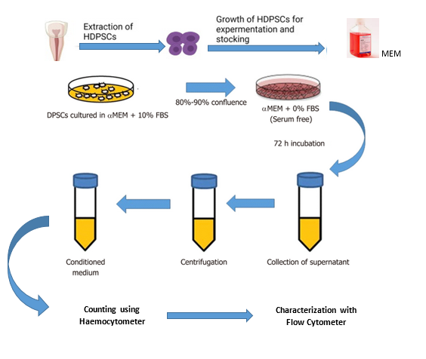
Figure 3.1. Overall architecture of the research work

COUNTING USING HAEMOCYTOMETER
The number of unattached cells was counted using a haemocytometer (HCM). Cell counting is an integral part of determining cell concentrations for plating in culture, determining cell viability, and assessing the results of cell isolation procedures. It is recommended to perform an initial cell count prior to cell isolation. This number can then be compared to the cell count after cell isolation to calculate cell recovery. Additionally, viable cell counts should be performed when a decrease in cell viability may be expected, for example, when working with cryopreserved cells or cells manipulated ex vivo.
Total nucleated Cell counting can be performed using Trypan Blue, Since it is recommended for counting viable mammalian cells. Trypan Blue penetrates the cell membrane, thus it enters the cytoplasm of cells with compromised membranes (dead cells) to stain them blue. The live cells remain intact and can be distinguished from dead cells by their ability to exclude the blue dye. In such case viable cells are counted. This protocol describes the method of performing viable cell counts by Trypan Blue dye exclusion.
- It is ensured that the cell suspension to be counted is completely resuspended. Before the cells settle, we placed a suitable volume of a cell suspension (20 - 200 μL) in a centrifuge tube.
- Added an equal volume of 0.4% Trypan Blue and gently mix.
- Incubated the mixture at room temperature (15°C – 25°C) for 5 minutes.

Materials
- Cell Culture Media: pre-warmed to the appropriate temperature
- 70% (v/v) alcohol in sterile water
- Trypan Blue Solution
- 0.1 % trypsin/EDTA in HBSS, without Ca²⁺/Mg²⁺

Equipment
- Personal protective equipment (sterile gloves, laboratory coat, safety visor)
- Waterbath set to appropriate temperature
- Microbiological safety cabinet at appropriate containment level
- Centrifuge
- CO₂ incubator
- Hemocytometer
- Inverted phase contrast microscope
- Pre-labelled flasks
- A hemocytometer is prepared by cleaning the chamber surface with 70% ethanol. Wiped dry. Positioned the coverslip over the chambers.
- Resuspended the cell mixture and place 10 μL of stained cells into the hemocytometer chamber using a 20 µL pipettor. Coverslip should not be moved The capillary action to draw the sample in was allowed.
- The hemocytometer was placed on the stage of a binocular light microscope. Adjusted the microscope to 10X magnification and focus on the cells.
- Using a hand tally counter, the study counted the cells (stained nuclei) in each of the four outside squares of the hemocytometer Figure 3.2.a , including cells that lie on the bottom and left-hand perimeters, but not those that lie on the top and right-hand perimeters (Figure 3.2.b). The unstained viable cells were counted.
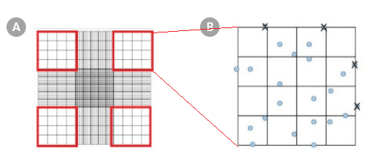
Figure 3.2 a and b. Hemocytometer Gridlines
​​Hemocytometer diagram indicating the (A) four sets in red and (B) the 16 squares within one of the sets that should be used for counting.
- The appropriate dilution factor depended on the approximate number of cells present in the starting sample but resulted in a cell concentration that gives 50 - 100 cells per square (i.e. large or major square) in the hemocytometer.
- If there are more or fewer than approximately 100 cells per major Square on the hemocytometer, the study prepared a new diluted sample using a greater or smaller dilution factor.
- Each of the nine major squares of the hemocytometer represents a total volume of 0.1 mm³. Since 1 cm³ is equivalent to 1 mL, the cell concentration can be determined using the following equation:
- Total number of nucleated cells/mL = average cell count per square x dilution factor x 10

CHARACTERIZATION OF hDPSCs

The isolated cell phenotype was characterized using the mesen-
chymal cells of human origin. The cultured cells were trypsinized and incubated in separate tubes with 10 μL of fluorochrome-conjugated monoclonal antibodies (CD34, CD45). Analysis was performed using a flow cytometer.
CD 34 Marker (Positive marker)
CD34 is predominantly regarded as a marker of hematopoietic stem cells (HSC) and hematopoietic progenitor cells. CD34 is a membrane protein that aids cells in cell-cell adhesion. Although little is known about its function, CD34 is an important marker for hematopoietic stem cells (HSCs), muscle satellite cells, and endothelial cells. HSCs can be found in bone marrow and blood of adults; however, because they are relatively rare, historically, HSCs have been difficult to study. The emergence of flow cytometry and FACS has facilitated the use of antibodies against CD34 to more readily identify, count and even purify these cells.
CD 45 Marker (Negative marker)
CD45 is a transmembrane protein tyrosine phosphatase located on most haematopoietic cells. It has several isoforms, and haematopoietic cells express one or more of the isoforms—CD45RO, CD45RA and CD45RB. CD45 immunoreactivity is recognised to be highly specific for hDPSCs. CD45 cell surface antigen is a transmembrane protein with tyrosine phosphatase activity, expressed by all nucleated cells of hematopoietic origin, except erythrocytes and platelets. ... As cell surface immunophenotype marker, CD45 is of great value in differentiation of lymphoproliferative diseases subtypes.
Flow cytometer analysis
- To characterize the immunophenotype of ex vivo expanded DPSC, flow cytometric analysis is used to measure the expression of surface markers CD 34 and CD 45 at cell passages. The relatively low number of cells initially harvested from the digestion of pulp tissue limits the use of flow cytometric analysis without ex vivo expansion.
- Adherent, expanded DPSC are washed once with HBSS and liberated by enzymatic digestion through the addition of 3 ml trypsin/EDTA solution per T-75 culture flask for 5 min at 37°C. The single cell suspension is then washed twice in HHF with centrifugation at 400 × g for 10 min. Cell count and assessment of viability are performed
- The stem cells are re-suspended for immunolabelling in 0.5 ml blocking buffer and incubate on ice for approximately 30 min to reduce the possibility of Fc receptor-mediated binding of antibodies.
- The individual 4 ml round bottom polypropelyne tubes containing 1 × 105 culture-expanded DPSC are incubated with appropriate primary murine monoclonal IgG antibodies or isotype-matched controls at a concentration of 10 mg/ml for purified antibodies or 1:2 diluted hybridoma supernatant for 1 h on ice.
- Wash the cells twice in 2 ml HHF as described above.
- The cells are incubated with the appropriate secondary detection reagent goat anti-mouse IgG1-fluorescein isothiocyanate (FITC)-conjugated antibody or anti-mouse IgM-FITC for 45 min on ice
- Washed the cells twice in 2 ml HHF with centrifugation at 400 × g for 10 min.
- Re-suspended cell pellet in 0.5 ml FACS Fix solution to each tube for 10 min.
- Analyzed the cells on any fluorescence-activated cell sorter fitted with a 250 MW argon laser emitting light at a wavelength of 488 nm and therefore able to detect FITC.

SUMMARY

This chapter summarize the methodology followed in the isolation, and characterization of hDPSCs. The materials and the appropriate methodology followed during the experimental analysis has been deliberated to provide insights about the research. Further these experimental procedures are accompanied with evaluation of the results in the next chapter.

CHAPTER 4
RESULTS AND DISCUSSION
Mesenchymal cells derived from neural crest are responsible for the construction of craniofacial skeleton during embryo and tooth-periodontium formation over fetal and adult life. These cells are involved in the development of several, although distinct, hard tissues, including crown and root dentin, cementum, and alveolar bone. So far, according to their common origin, it has not been feasible to identify a specific marker for differentiated cells of each of these structures. This section represents the results and discussion of the experiment. Further the obtained results was discussed with the state of art methods. The figure 4.1. represents the extraction of hDPSC from healthy individual. Similar to the present study also isolated hDPSC from MEM medium. This study characterized and compared two subpopulations of adult stem cells derived from human dental pulp (hDPSCs). Figure 2 state that the extracted tooth was sectioned with the use of high speed hand-piece for obtaining the entire pulp tissue. investigated proliferative potential of hDPSCs with different concentration of concentrated growth factor and evaluated by Cell Counting Kit-8. For the purpose the study sectioned the tooth by similar method. The following figure 4.3. is the digestion of splitted tooth by the enzymatic dissociation are performed by incubating the samples in a medium comprising collagenase (3 mg/ ML) and dispase (4mg/ml) for 16 hours at 37°C with 5% carbon di oxide., also performed similar method of digestion for further analysis.

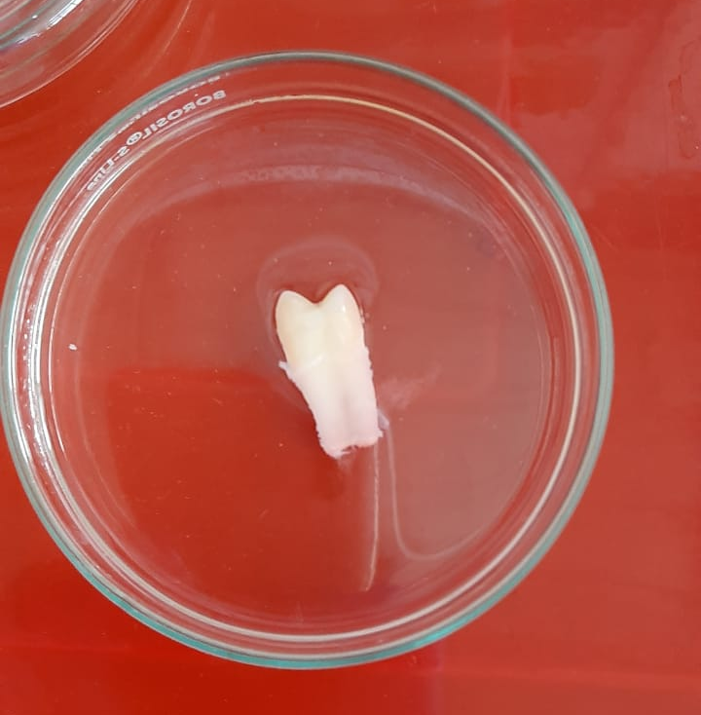
Figure 4.1. Extraction of hDPSC from healthy individual by MEM method

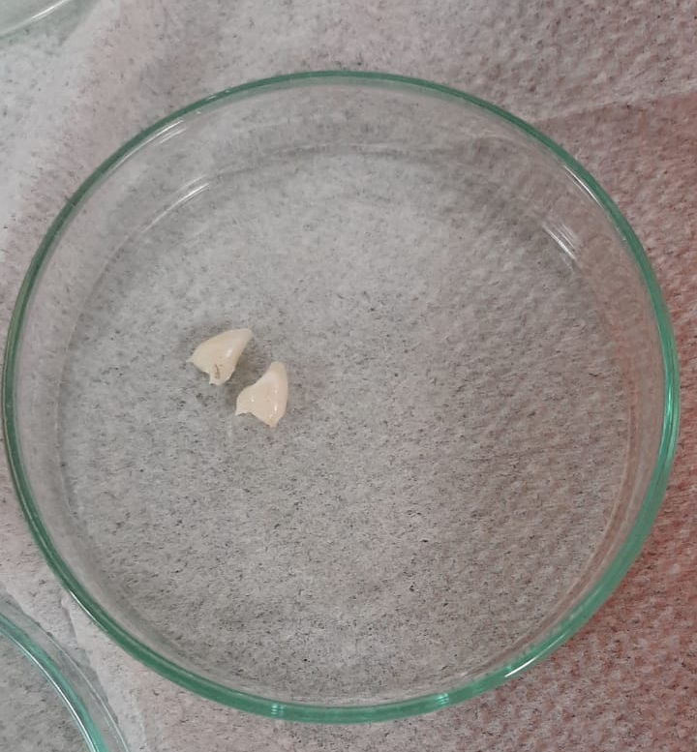
Figure 4.2. Sectioning of the tooth

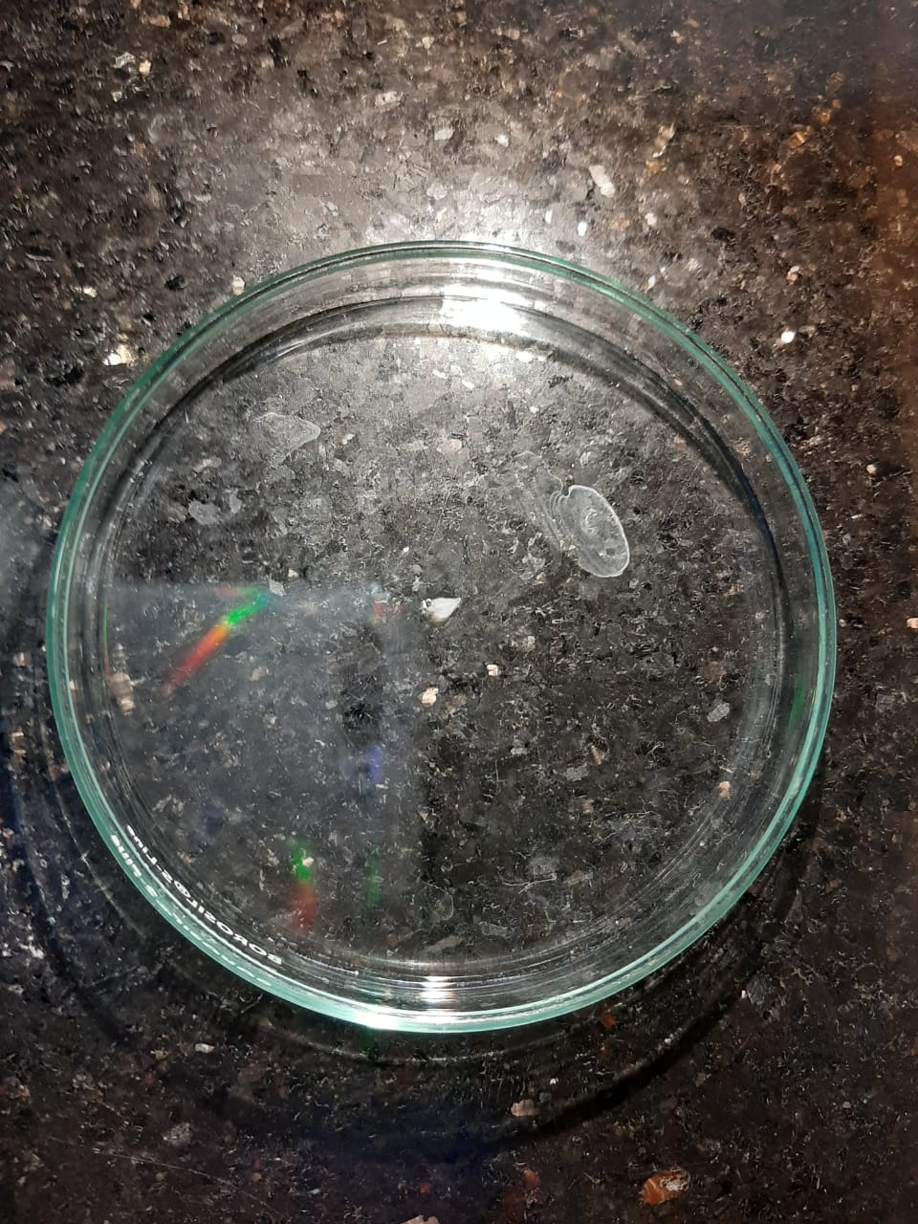
Figure 4.3. Enzymatic digestion of the extracted and the sectioned tooth.

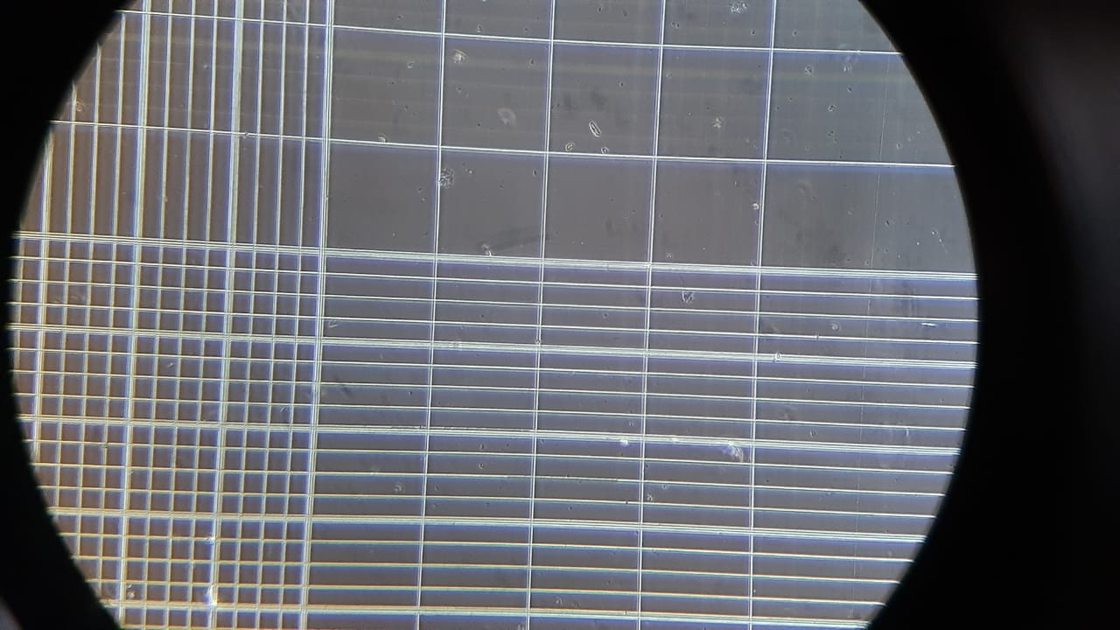
Figure 4.4. Cell Counting using haemocytometer
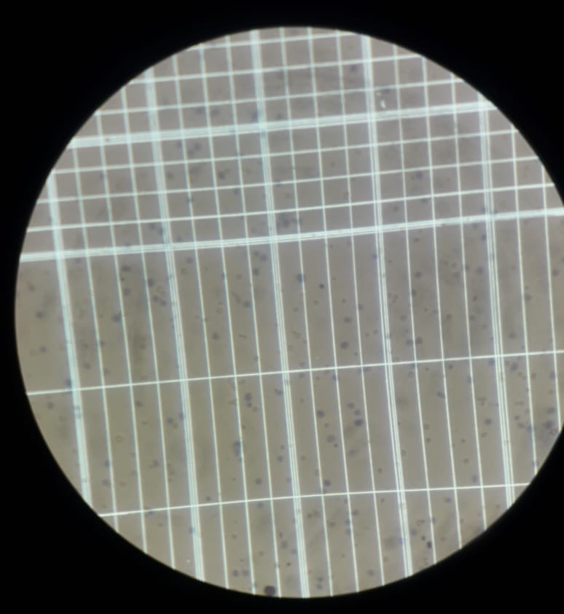
Figure 4.5. Cell Counting using haemocytometer

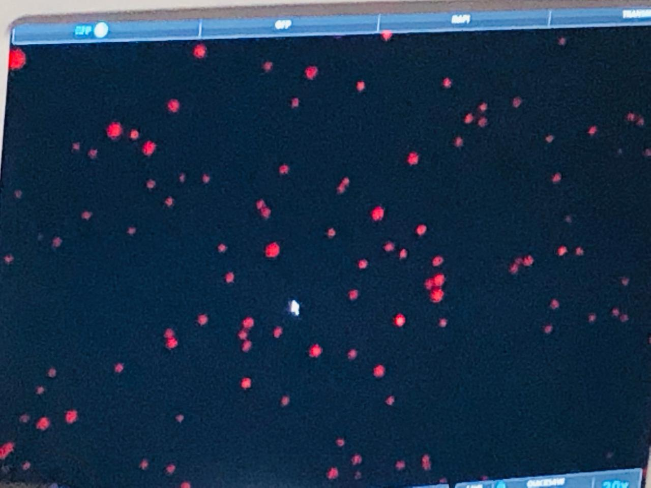
Figure 4.6. Flow cytometry

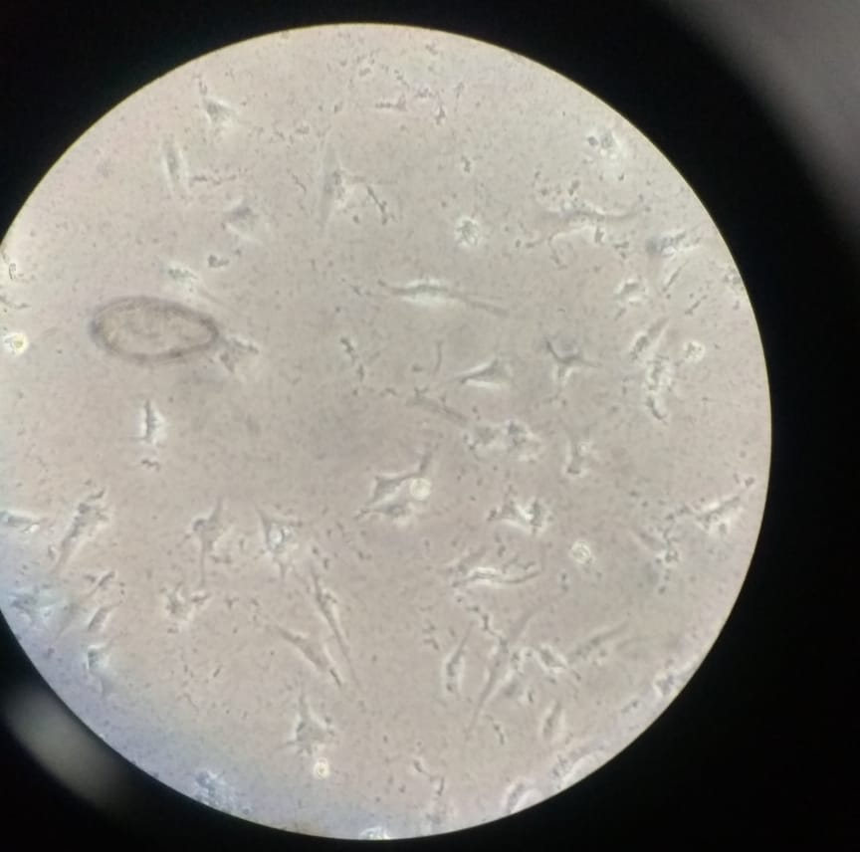
Figure 4.7. Flow cytometry
Figure 4.4 and Figure 4.6 shows the counting of the digested hDPSC using haemocytometer. Various existing studies performed haemocytometer to determine the counts. These countings were used for the determination of viable cells. Figure 4.6 and 4.7 represents the results of flow cytometric analysis of hDPSCs for characterization of cells with the surface markers CD 45 and CD 34. These results trigger further analyses to deeply investigate the hypothesis that more than a single stem cell population resides within the dental pulp, to better define the flexibility of application of hDPSCs in regenerative medicine.

CONCLUSION
Putative stem cell populations from the dental pulp of human third molars (dental pulp stem cells; DPSC) and deciduous teeth (stem cells from human exfoliated deciduous teeth; SHED) which exhibit similar properties to bone marrow derived mesenchymal stem cells have been identified. Motivated by these facts, This thesis provided the information about the isolation, counting, differentiation and molecular characterization of DPSCs to different kinds of human cells and hence these cells possess significant applications in the regenerative therapy. Human dental pulp represents a suitable alternative source of stem cells for the purpose of cell-based therapies in regenerative medicine, because it is relatively easy to obtain it, using low invasive procedures.

REFERENCES

Ahmed, N. E.-M. B., Aly, R. M., Abd El-Massieh, P. M., & Abd El Azeem, A. F. (2018). Comparing the stemness properties of dental pulp cells (DPSCs), collected, processed, and cryopreserved under different conditions. Journal of Stem Cells, 13(2), 95-106.
Amiryaghoubi, N., Pesyan, N. N., Fathi, M., & Omidi, Y. (2020). Injectable thermosensitive hybrid hydrogel containing graphene oxide and chitosan as dental pulp stem cells scaffold for bone tissue engineering. International journal of biological macromolecules, 162, 1338-1357.
Anitua, E., Troya, M., & Zalduendo, M. (2018). Progress in the use of dental pulp stem cells in regenerative medicine. Cytotherapy, 20(4), 479-498.
di Napoli, A. Amniotic fluid-derived MSCs lead to bone differentiation when co-cultured with dental pulp stem cells.
Di Scipio, F., Sprio, A. E., Carere, M. E., Yang, Z., & Berta, G. N. (2017). A simple protocol to isolate, characterize, and expand dental pulp stem cells Adult Stem Cells (pp. 1-13): Springer.
Dong, Q., Wang, Y., Mohabatpour, F., Zheng, L., Papagerakis, S., Chen, D., & Papagerakis, P. (2019). Dental pulp stem cells: isolation, characterization, expansion, and odontoblast differentiation for tissue engineering Odontogenesis (pp. 91-101): Springer.
Goudarzi, G., Hamidabadi, H. G., Bojnordi, M. N., Hedayatpour, A., Niapour, A., Zahiri, M., . . . Darabi, S. (2020). Role of cerebrospinal fluid in differentiation of human dental pulp stem cells into neuron-like cells. Anatomy & cell biology, 53(3), 292-300.
Iwanaka, T., Yamaza, T., Sonoda, S., Yoshimaru, K., Matsuura, T., Yamaza, H., . . . Taguchi, T. (2020). A model study for the manufacture and validation of clinical-grade deciduous dental pulp stem cells for chronic liver fibrosis treatment. Stem Cell Research & Therapy, 11(1), 1-19.
Jin, R., Song, G., Chai, J., Gou, X., Yuan, G., & Chen, Z. (2018). Effects of concentrated growth factor on proliferation, migration, and differentiation of human dental pulp stem cells in vitro. Journal of tissue engineering, 9, 2041731418817505.
Kaneko, T., Gu, B., Sone, P. P., Zaw, S. Y. M., Murano, H., Zaw, Z. C. T., & Okiji, T. (2018). Dental pulp tissue engineering using mesenchymal stem cells: a review with a protocol. Stem cell reviews and reports, 14(5), 668-676.
Kim, Y. J., Park, S. G., Shin, B., Kim, J., Kim, S. W., Choo, O. S., . . . Choung, Y. H. (2017). Osteogenesis for postoperative temporal bone defects using human ear adipose‐derived stromal cells and tissue engineering: an animal model study. Journal of Biomedical Materials Research Part A, 105(12), 3493-3501.
Li, D., Zou, X.-Y., El-Ayachi, I., Romero, L. O., Yu, Z., Iglesias-Linares, A., . . . Huang, G. T.-J. (2019). Human dental pulp stem cells and gingival mesenchymal stem cells display action potential capacity in vitro after neuronogenic differentiation. Stem cell reviews and reports, 15(1), 67-81.
Nakajima, K., Kunimatsu, R., Ando, K., Ando, T., Hayashi, Y., Kihara, T., . . . Kaku, M. (2018). Comparison of the bone regeneration ability between stem cells from human exfoliated deciduous teeth, human dental pulp stem cells and human bone marrow mesenchymal stem cells. Biochemical and biophysical research communications, 497(3), 876-882.
Ono‐Uruga, Y., Ikeda, Y., & Matsubara, Y. (2021). Platelet production using adipose‐derived mesenchymal stem cells: Mechanistic studies and clinical application. Journal of Thrombosis and Haemostasis, 19(2), 342-350.
Pagella, P., Miran, S., Neto, E., Martin, I., Lamghari, M., & Mitsiadis, T. A. (2020). Human dental pulp stem cells exhibit enhanced properties in comparison to human bone marrow stem cells on neurites outgrowth. The FASEB Journal, 34(4), 5499-5511.
Pisciotta, A., Carnevale, G., Meloni, S., Riccio, M., De Biasi, S., Gibellini, L., . . . De Pol, A. (2015). Human dental pulp stem cells (hDPSCs): isolation, enrichment and comparative differentiation of two sub-populations. BMC developmental biology, 15(1), 1-16.
Rosales Ibáñez, R., Cubo Mateo, N., Rodríguez Lorenzo, L. M., Rodríguez Navarrete, A., & Flores Sánchez María, L. O. (2019). Potential benefits from 3D printing and dental pulp stem cells in cleft palate treatments: an in vivo model study.
Sabbagh, J., Ghassibe-Sabbagh, M., Fayyad-Kazan, M., Al-Nemer, F., Fahed, J. C., Berberi, A., & Badran, B. (2020). Differences in osteogenic and odontogenic differentiation potential of DPSCs and SHED. Journal of Dentistry, 101, 103413.
Sarwary, R., Santamaria, N., Sridharan, K., & Rueda, M. Human Dental Pulp Stem Cells (DPSCs): A Systematic Review on Isolation Techniques and Markers Used for In-Vitro Characterisation. Available at SSRN 3661929.
Xu, F., Qiao, L., Zhao, Y., Chen, W., Hong, S., Pan, J., & Jiang, B. (2019). The potential application of concentrated growth factor in pulp regeneration: an in vitro and in vivo study. Stem cell research & therapy, 10(1), 1-16.
Yang, T., Zhang, Q., Xie, L., Zhang, R., Qian, R., Tian, Y., . . . Tian, W. (2021). hDPSC-laden GelMA microspheres fabricated using electrostatic microdroplet method for endodontic regeneration. Materials Science and Engineering: C, 121, 111850.
Yasui, T., Mabuchi, Y., Morikawa, S., Onizawa, K., Akazawa, C., Nakagawa, T., . . . Matsuzaki, Y. (2017). Isolation of dental pulp stem cells with high osteogenic potential. Inflammation and regeneration, 37(1), 1-10.
Yazid, F., Luchman, N. A., Wahab, R. M. A., & Ariffin, S. H. Z. (2018). Comparison of Characterization and Osteoblast Formation Between Human Dental Pulp Stem Cells (hDPSC) and Stem Cells from Deciduous Teeth (SHED). Paper presented at the Proceedings of the Second International Conference on the Future of ASEAN (ICoFA) 2017–Volume 2.
Zhou, H., Li, X., Yin, Y., He, X.-T., An, Y., Tian, B.-M., . . . Chen, F.-M. (2020). The proangiogenic effects of extracellular vesicles secreted by dental pulp stem cells derived from periodontally compromised teeth. Stem Cell Research & Therapy, 11(1), 1-18.

